

Standard Data Gateways

Quorum Network Resources Ltd

Robert French

March 2023

# Contents

1. Contents 2

2. Document control 3

2.1. Revision history 3

3. Overview 3

3.1. Introduction 3

3.2. How do they work? 3

3.3. Architecture 3

4. Requirements 4

4.1. Minimum requirements 4

4.2. Recommended 4

4.3. Firewall gateway ports 5

4.4. Related considerations 5

4.4.1. Installation environment constraints 5

4.4.2. Other considerations 5

5. Installing standard data gateway 6

5.1. Prerequisites 6

5.2. Installation process 6

6. Monitoring and optimisation 11

7. Default Service Account 11

8. VNet Gateway 11

9. References 12

# Document control

## Revision history

|  |  |  |  |
| --- | --- | --- | --- |
| ***Version #*** | **Date** | **Reason for release** | **Name** |
| V1 | 1st March 2023 | First Draft | Robert French |
| V2 | 25th June 2024 | Added details on what must be captured in the IT boost when installed by service desk members for clients. Edited some images to make them smaller without removing any required detail. | Robert French |
| V2.1 | 21st March 2025 | Added section on Firewall settings | Robert French |

# Overview

## Introduction

Since Power BI is a cloud service, specific software is required to access on-premise data sources. The software that allows this secure access to the data in an on-premise data source is the Data Gateway. Additionally, it can be used to access data sources hosted on an Azure cloud environment.

## How do they work?

It is a Windows service running on a specific Windows machine. The data gateway connects securely to the Power BI cloud service and the on-premise Gateway. First, requests for data from the Power BI service are passed to the Gateway, which processes the queries and passes them to the data source. In turn, the data source processes the queries and returns the data requested. Next, the data gateway spools the data back to the Power BI service.

## Architecture

The diagram below is a simplified example of the architecture for the Data Gateway. Note that the Data Gateway only makes an outgoing call to Azure Services, so **no** incoming connections are required for the Data Gateway.

Further details can be found in the reference document listed below

Reference - [On-premises data gateway architecture | Microsoft Learn](https://learn.microsoft.com/en-us/data-integration/gateway/service-gateway-onprem-indepth)

More detailed security information can be found at this link - [Power BI security white paper - Power BI | Microsoft Learn](https://learn.microsoft.com/en-us/power-bi/guidance/whitepaper-powerbi-security)

# Requirements

## Minimum requirements

* .NET Framework 4.7.2 (Gateway release December 2020 and earlier)
* .NET Framework 4.8 (Gateway release February 2021 and later)
* A 64-bit version of Windows 10 or a 64-bit version of Windows Server 2012 R2 with current TLS 1.2 and cipher suites
* 4 GB disk space for performance monitoring logs (in the default configuration)

Azure Machine -

Reference - [Install an on-premises data gateway | Microsoft Learn](https://learn.microsoft.com/en-us/data-integration/gateway/service-gateway-install)

## Recommended

* An 8-core CPU
* 8 GB of memory
* A 64-bit version of Windows Server 2012 R2 or later
* Solid-state drive (SSD) storage for spooling

Azure Machine -

Reference - [Install an on-premises data gateway | Microsoft Learn](https://learn.microsoft.com/en-us/data-integration/gateway/service-gateway-install)

## Firewall gateway ports

Gateway does not require any inbound ports to be open, and it defaults to the outbound ports of TCP 443 (default), 5672, 9350 and 9354 to communicate with the Azure Service Bus. Note the Gateway can be forced to use HTTPS communication exclusively ([using the Data Gateway App](https://learn.microsoft.com/en-us/data-integration/gateway/service-gateway-app)), avoiding using IP addresses via both the UI and the configuration files directly, which may impair performance.

## Related considerations

### Installation environment constraints

Gateways aren't supported on server-core installations or Windows containers.

The Gateway can't be installed on a domain controller.

It is recommended not to install a gateway on a computer, such as a laptop, that might be turned off, asleep, or disconnected from the internet. The Gateway will not operate under any of those circumstances.

If a machine on which the Gateway is installed uses a wireless network, its performance might suffer.

If you use a virtualisation layer for your virtual machine, performance might suffer or perform inconsistently. Therefore, we recommend setting the Gateway on a wired device for the best network performance.

You could install other applications on the gateway machine, but these applications might degrade gateway performance. If you install other applications on the gateway machine, monitor the Gateway closely to check for resource contention. So, installing the Gateway on a machine running a database application is not recommended.

You can install up to two gateways on a single computer: one in personal mode and the other in standard mode. An on-premises data gateway (personal mode) can be used only with Power BI. You can't have more than one Gateway running in the same mode on the same computer.

The data gateway (standard mode) must be installed on a domain-joined machine with a trust relationship with the target domain.

The user installing the Gateway must be the admin of the machine on which the Data Gateway is being installed.

If you plan to use Windows authentication, install the Gateway on a computer that's a member of the same Active Directory environment as the data sources.

### Other considerations

When a private link is enabled, turn off the private link before installing the Gateway. After installation, you can re-enable it. If a private link is enabled, you'll get the following error when trying to register a new gateway or migrate/restore/take over an existing gateway:

System.NullReferenceException: Object reference not set to an instance of an object

At - Microsoft.PowerBI.DataMovement.GatewayCommon.DmtsGatewayCreation.UpdateGatewayConfiguration.

To turn off the private link, go to the powerbi.com page and select Settings > Admin portal. Look for the Advanced networking section at the bottom of the page, and disable the Azure Private Link property. After configuring the Gateway, you can enable the Azure Private Link property.

# Installing standard data gateway

## Prerequisites

* **Download the Standard mode data gateway** from this location - <https://powerbi.microsoft.com/en-us/gateway/>
* **An organisational Entra account must have a Fabric Free licence assigned to the account**. This Entra account will be recorded in IT Boost for later reference.
* **Name for the DataGateway** – Confirm the name of the data gateway and ensure that it follows the client's naming convention. By default, the name of the data gateway is the name of the VM on which the data gateway is running.
* **Recovery Key – which is an alphanumeric value of a minimum of eight characters**. This value will be recorded in IT Boost for later reference.

## Installation process

Download from this page - <https://powerbi.microsoft.com/en-us/gateway/>. The Standard Mode data gateway is on the machine intended to install the data gateway. Then, open the .exe file and accept the terms of use. Keep the default installation path, then click the 'Install' button.

In the next window, sign in with an organisation account that has access to the organisation's Power BI service. This account must have at least a Free Power BI account assigned to it, and it would be preferable to have a Power BI Pro account; this is **not** a prerequisite. Note this step ensures the Data Gateway is associated with the organisation's Power BI service.

The next step is to register a new Data Gateway on the computer on which this installer is being run.

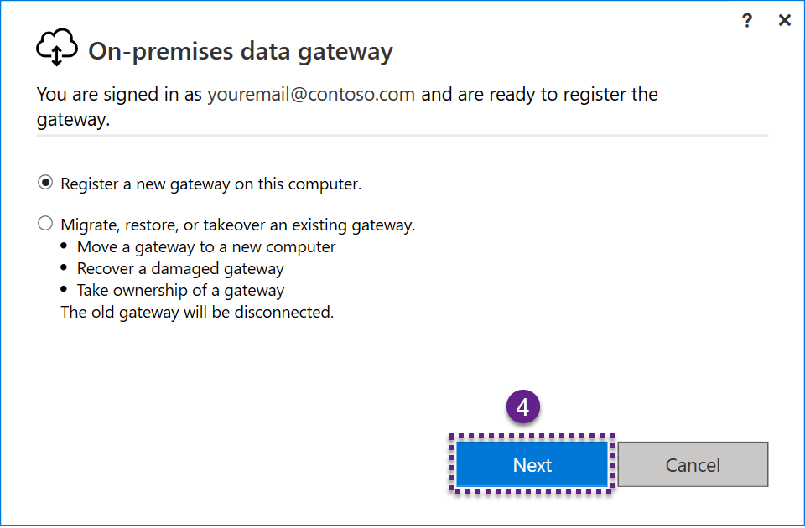

Now, enter the name of the installed data gateway. Note this should be unique to the Power BI service which it is associated with.

A recovery key must also be entered. The recovery key should be stored in IT boost for the client for which the data gateway is installed. This recovery key will be used to restore the Data Gateway in the event of recovery or moving the Data Gateway. If the recovery key is not provided, all the data source credentials must be re-entered. Click the ' Configure ' button once all the relevant details have been entered.

The final step is to review the information presented in the window displayed. Then, to confirm that the Data Gateway has been configured as intended.

The final screen will look like the one below, confirming that the Gateway has been installed successfully and is now running.

Best practice recommends that HTTPS mode is enabled.

# Monitoring and optimisation

There are at least two methods for monitoring the performance of the Data Gateway. One is to monitor the performance counters from the [Windows performance monitoring tool.](https://techcommunity.microsoft.com/t5/ask-the-performance-team/windows-performance-monitor-overview/ba-p/375481)

If the Standard Data Gateway is installed, it is possible to get additional query logging. In addition, Microsoft has created a [Gateway Performance PBI template file](https://download.microsoft.com/download/b/1/b/b1b229f4-a142-4d8a-8968-19e4ae95bc37/OnPremiseDataGatewayLogs.pbit). The template file will allow more significant insights into Standard Data Gateway and the ability to visualise query performance.

More details can be found [on this page](https://learn.microsoft.com/en-us/data-integration/gateway/service-gateway-performance).

# Default Service Account

The Data Gateway, by default, will run under the following service account – 'NT SERVICE\PBIEgwService.'

The following location - *C:\Users\PBIEgwService\AppData\Local\Microsoft\On-premises* is the default location where the Data Gateway spools data. If there is an out-of-disk error, this is one possible reason for that error message. Data is temporarily cached by the Data Gateway when a request is fulfilled. For more information, [see this page](https://learn.microsoft.com/en-us/data-integration/gateway/service-gateway-configure-disk-space#gateway-spooling-data).

# Firewall settings

When installing the data gateway, there are a number of ports that are required to be accessible. This link lists <https://learn.microsoft.com/en-us/fabric/security/power-bi-allow-list-urls> all th URL’s and ports that are required to be accessible from the machine on which the datagateway is running on.

# VNet Gateway

Microsoft also offers a different product, which is the VNET data gateway. Microsoft entirely manages an IaasS (Infrastructure as a service) product and such. To use the VNET data gateway then, the requirement is a Premium capacity, which is defined as the following;

Any Fabric (F-SKU)

Power BI Premium SKU – P1 or higher *

Azure SKU – A4 or higher *

* That P-SKUs are being retired, and F-SKUs have a superset of the A-SKU features.

Given that the VNET data gateway is a fully managed solution by Microsoft, this would be our recommended solution for any customer.

# References

<https://docs.microsoft.com/en-us/data-integration/gateway/>

<https://docs.microsoft.com/en-us/data-integration/gateway/service-gateway-onprem-indepth>

<https://docs.microsoft.com/en-gb/power-bi/connect-data/service-gateway-onprem>

<https://docs.microsoft.com/en-us/power-bi/connect-data/service-gateway-deployment-guidance>

<https://docs.microsoft.com/en-us/data-integration/gateway/service-gateway-monthly-updates>

<https://learn.microsoft.com/en-us/power-bi/guidance/whitepaper-powerbi-security>

Quorum Network Resources Limited  
18 Greenside Lane, Edinburgh, EH1 3AH

[www.qnrl.com](http://www.qnrl.com/) | [info@qnrl.com](mailto:info@qnrl.com)

Reg. No. SC 196645, Registered Office: 24a Melville Street, Edinburgh EH3 7NS.